Exercise 1: Analogy of Elements and Principles

Growing a plant. You need to *place* the **seeds** in the ground. *Bury* more **soil** on top. *Place* the **fertilizer** on top. *Pour* the **water** over the seeds.

. 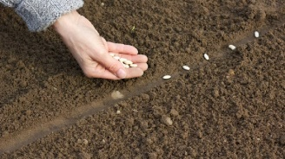

Exercise 2

Man made items and careers

1. Graphic designer
2. Painter
3. Interior designer
4. Animator
5. Editors
6. Writers
7. Architect
8. Fashion designer
9. Marketers
10. Engineer
11. Industrial designer
12. Woodworker
13. Jeweler
14. Makeup artist
15. Glassblower

